**Model Drawing Examples: Addition & Subtraction**

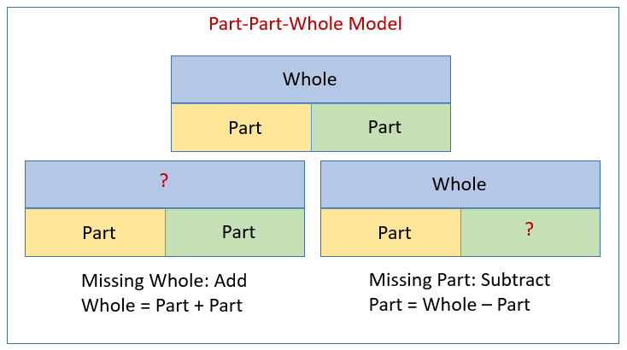

**Missing Whole or Whole Unknown**  
Example: Connie has 15 red marbles and 28 blue marbles. How many marbles   
does she have?   
We are given the parts and we need to find the whole. This would involve addition.  
15 + 28 = 43

|  |  |  |  |
| --- | --- | --- | --- |
|  | Answer statement | Model Drawing | Calculation |
| Example 1 | Connie has 43 total marbles. |  | 15 + 28  (10 + 5) + (20 + 8)  10 + 20=30  5 + 8 =13  30+ 13 = 43 |

**Missing Part or Part Unknown**  
Example: Connie has 43 marbles. 15 are red and the rest are blue. How many   
blue marbles does Connie have?   
We are given the whole and we need to find the part. This would involve subtraction.  
43 - 15 = 28

|  |  |  |  |
| --- | --- | --- | --- |
|  | Answer statement | Model Drawing | Calculation |
| Example 2 | Connie has 28 blue marbles. |  |  |

**Comparison Model Drawing Example**

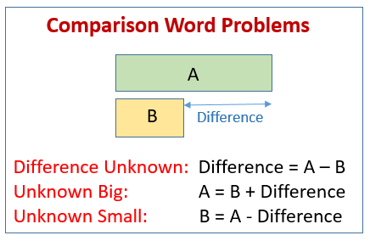

**Difference Unknown**  
Connie has 15 red marbles and 28 blue marbles. How many more blue marbles than red marbles does Connie have?   
This is a subtraction problem.   
28 - 15 = 13

|  |  |  |  |
| --- | --- | --- | --- |
|  | Answer statement | Model Drawing | Calculation |
| Example 3 | Connie has 13 more blue marbles than red marbles. |  |  |